**Design Documents**

**Design Prototype #1 - Selected**

Mobile: <https://jagx9j.axshare.com/#id=6kr2iu&p=login_register&g=1>

Desktop: <https://k23tr4.axshare.com/#id=4vzrml&p=forum_discussion_page&g=1>

**Login page**

*Mobile version:*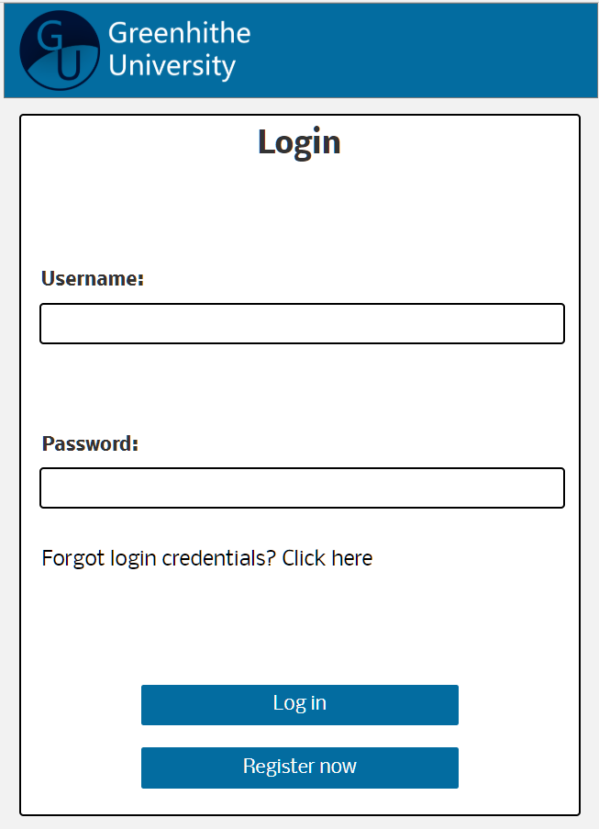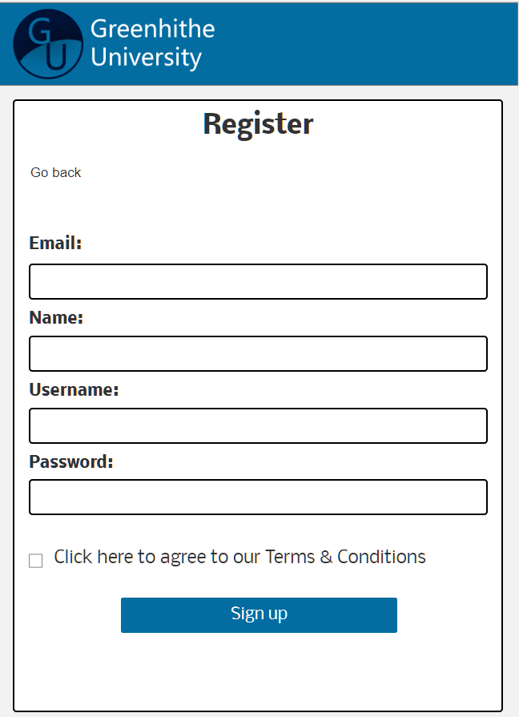

*Desktop version:*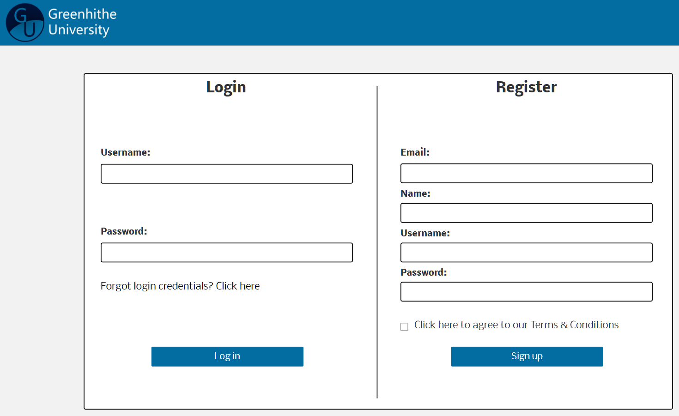

**Individual idea**

*Mobile:*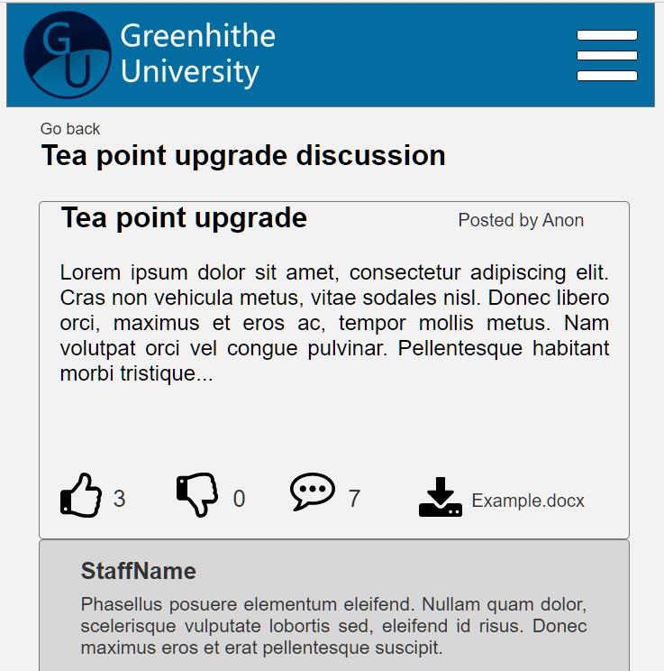

*Desktop:*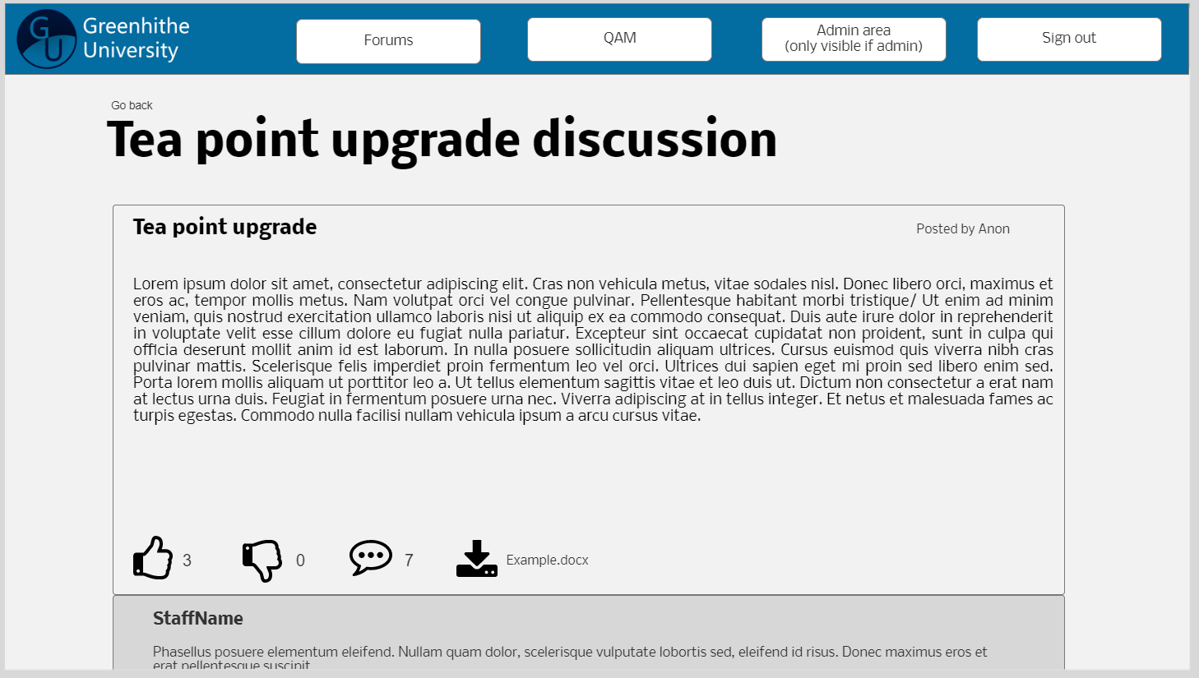

**Analytics**

*Mobile:*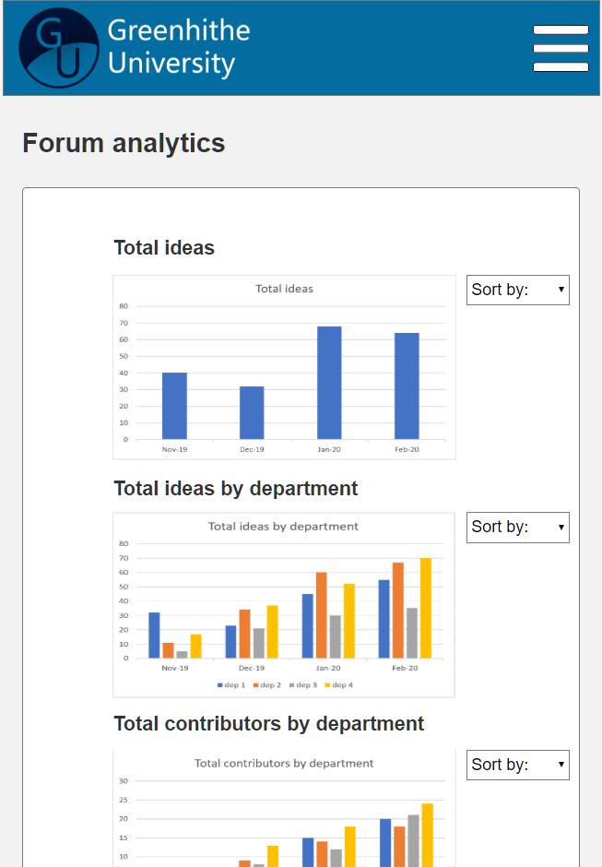

*Desktop:*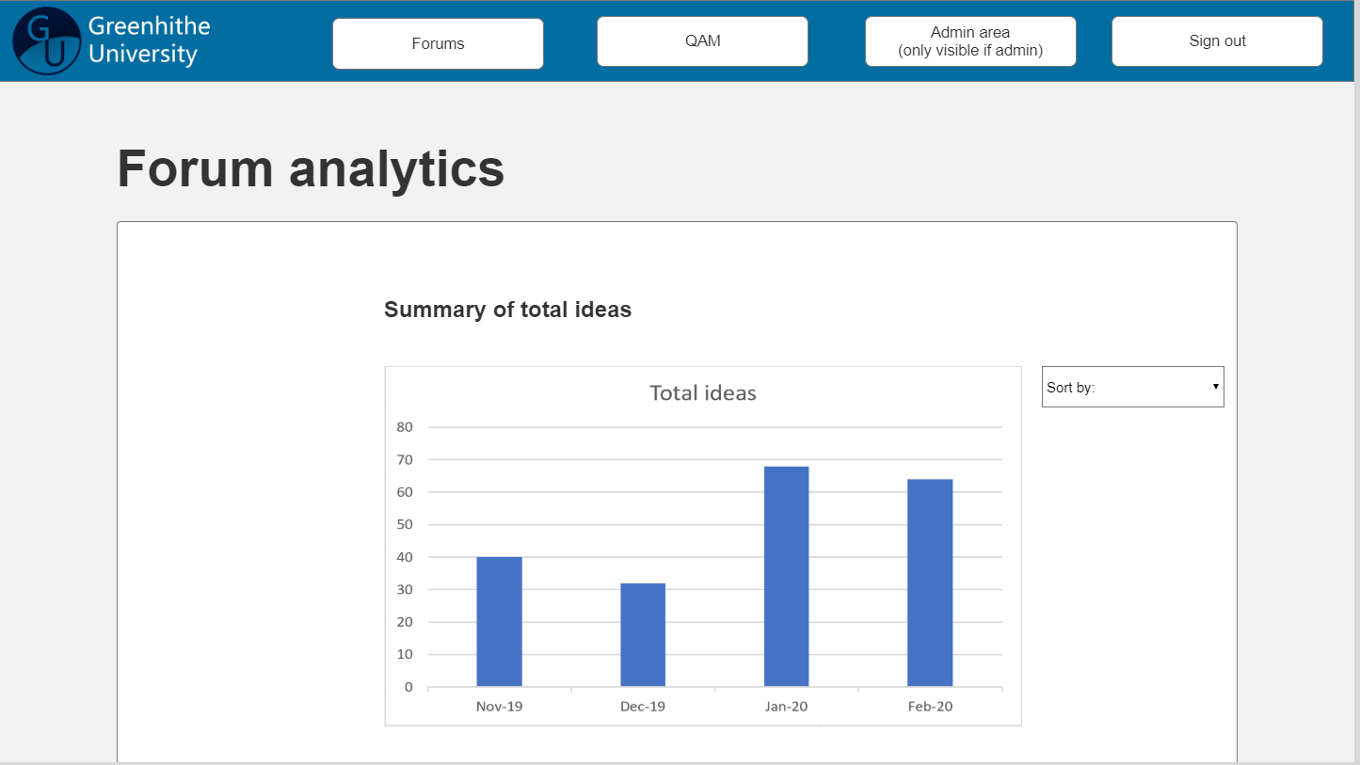

**View ideas per category**

*Mobile:*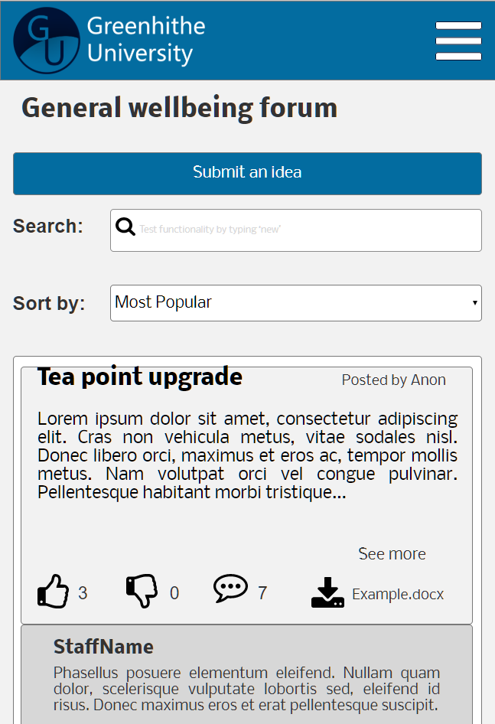

*Desktop:*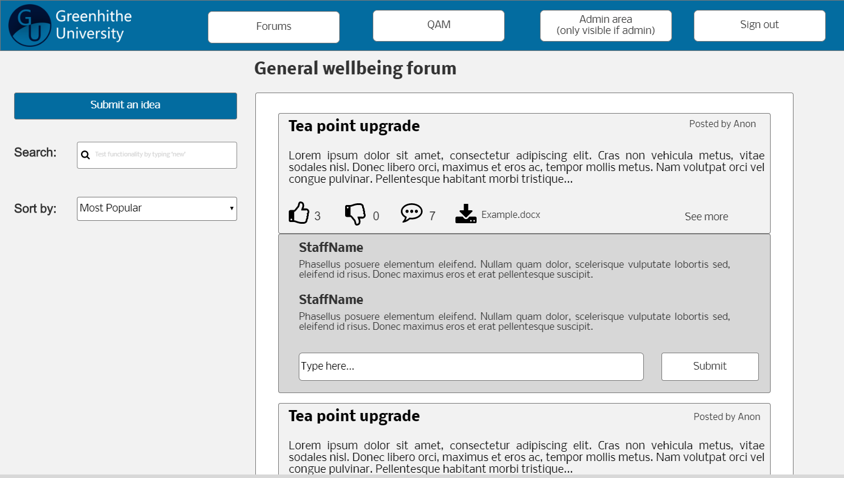

**Idea category selection**

*Mobile:*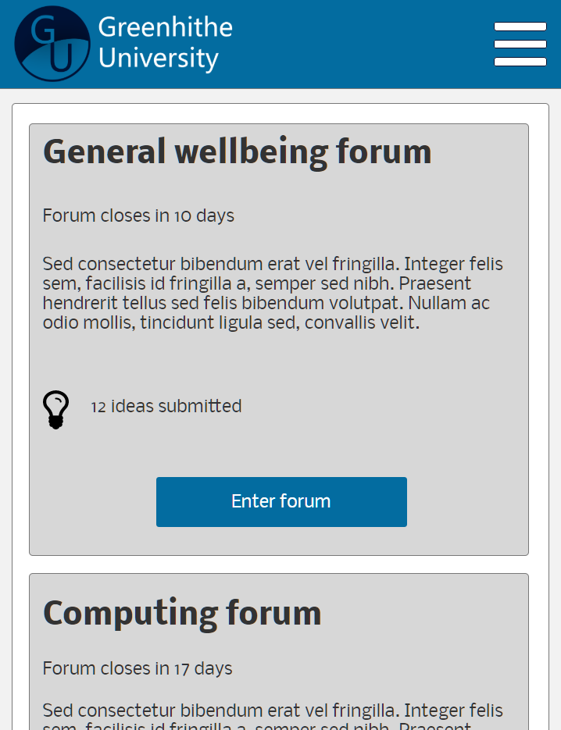

*Desktop:*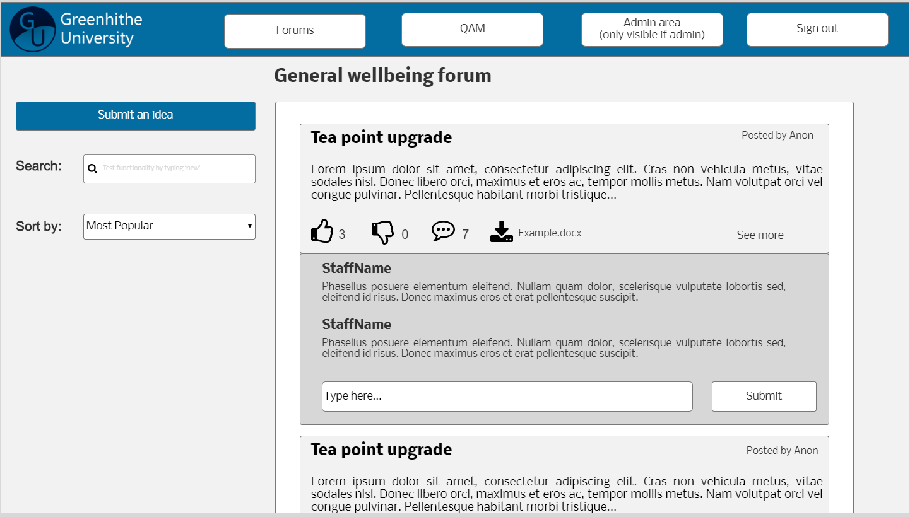

**Administration panel**

*Mobile:*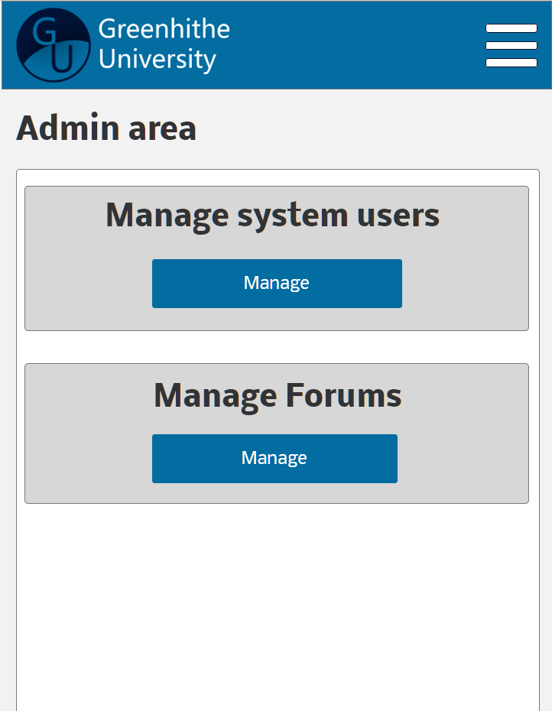

*Desktop:*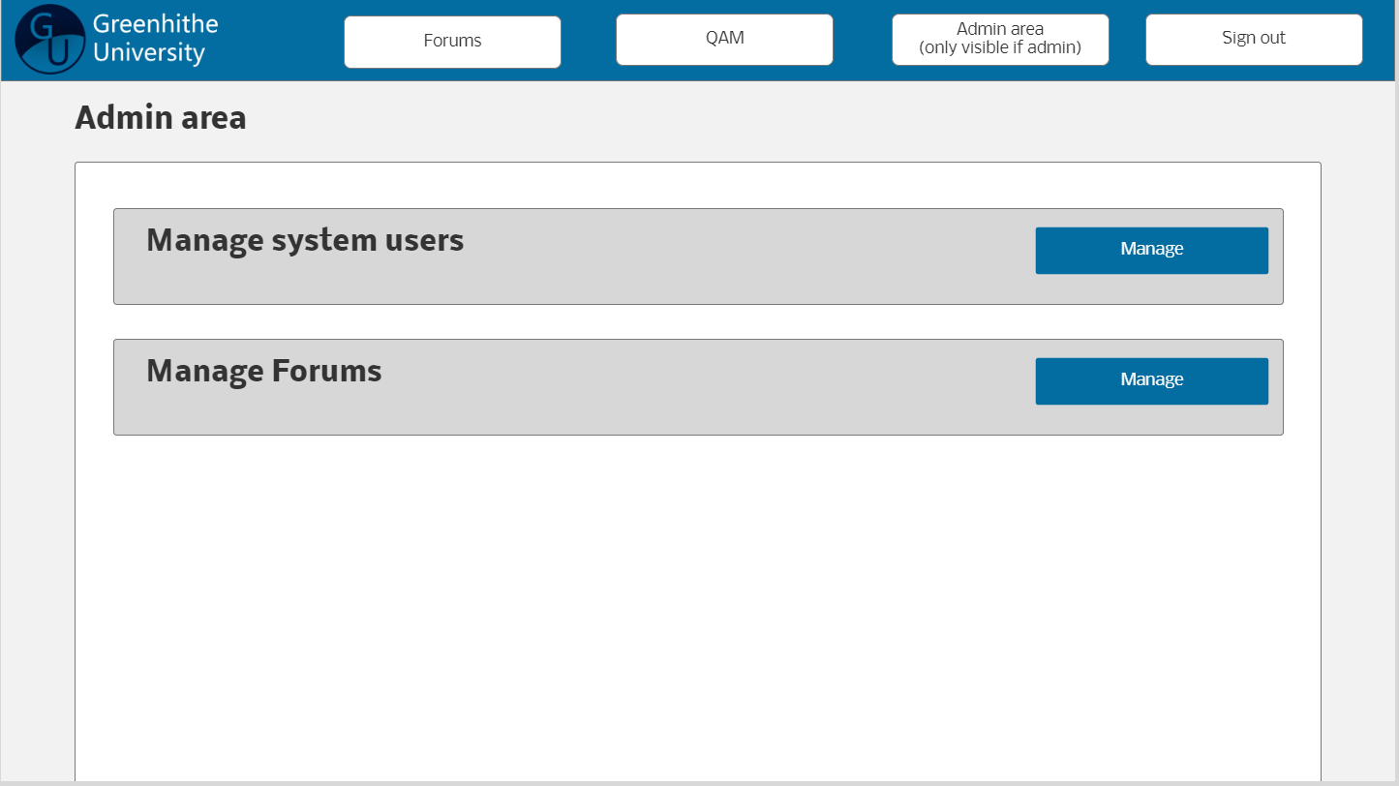

**Design Prototype #2 - Alternate**

Design: <https://nisheekanynan.proto.io/billing/status/trial-expired/>

Username: nn1459j@greenwich.ac.uk

Password: password12345

**Login page**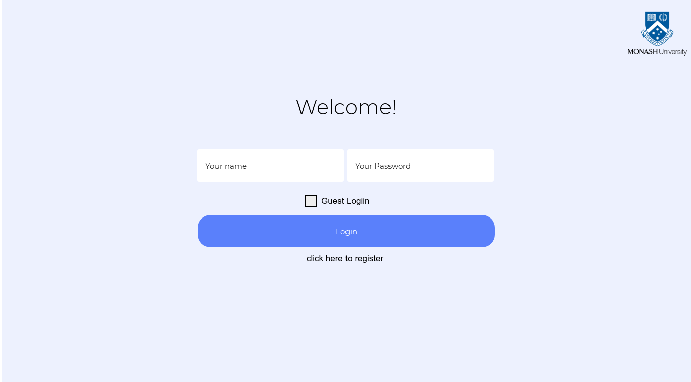

**Registration**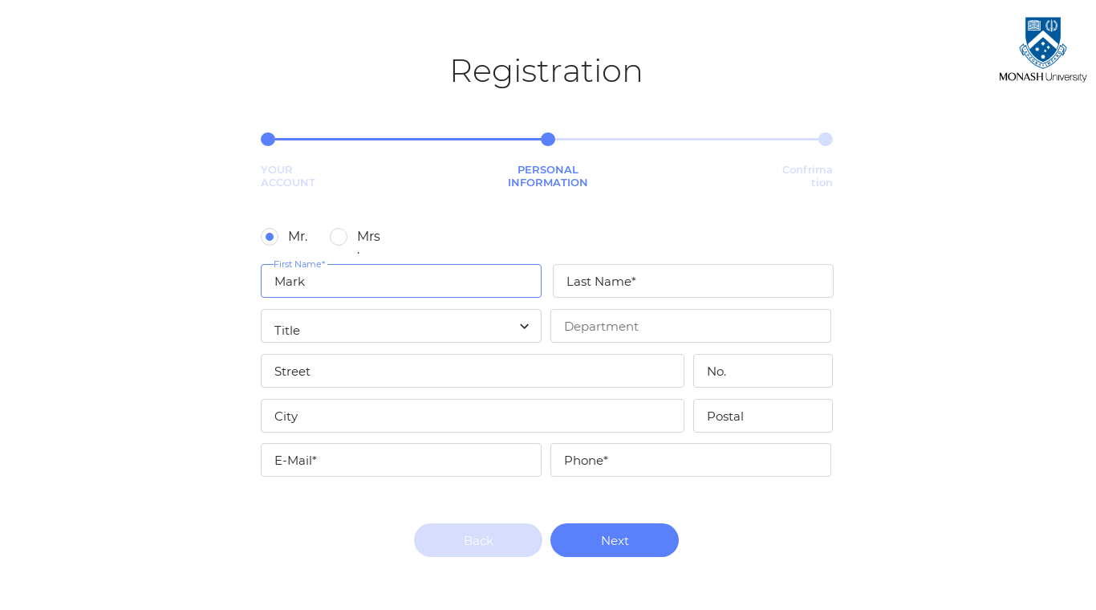

**Idea submission**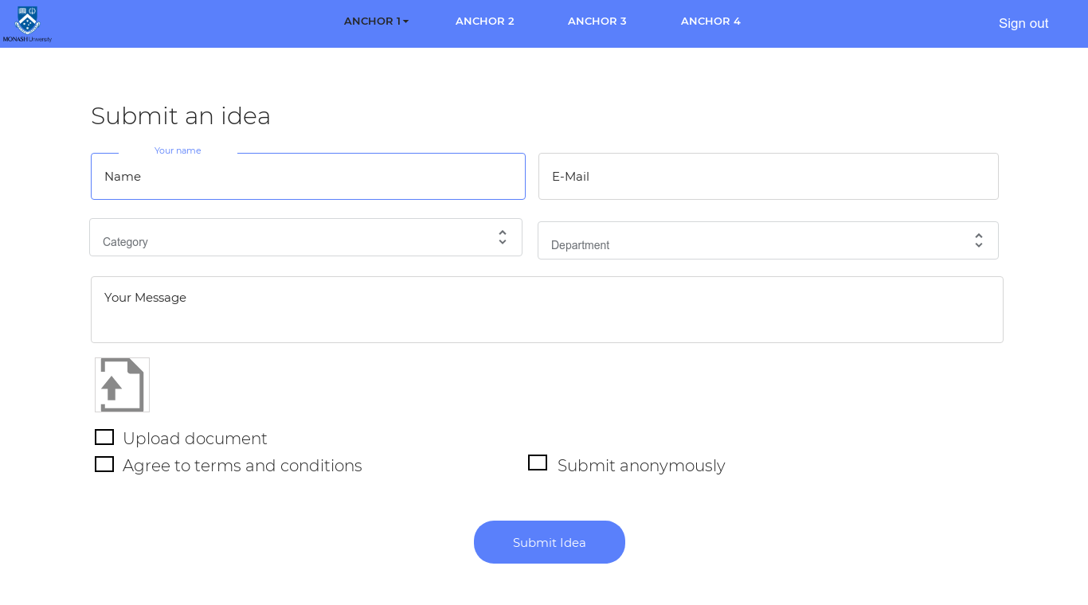

**List of ideas**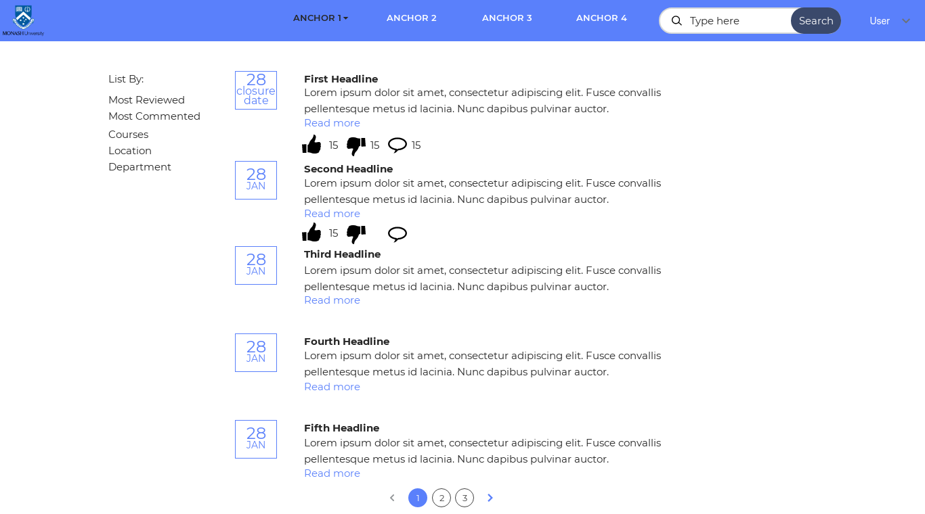

**Detailed view of idea**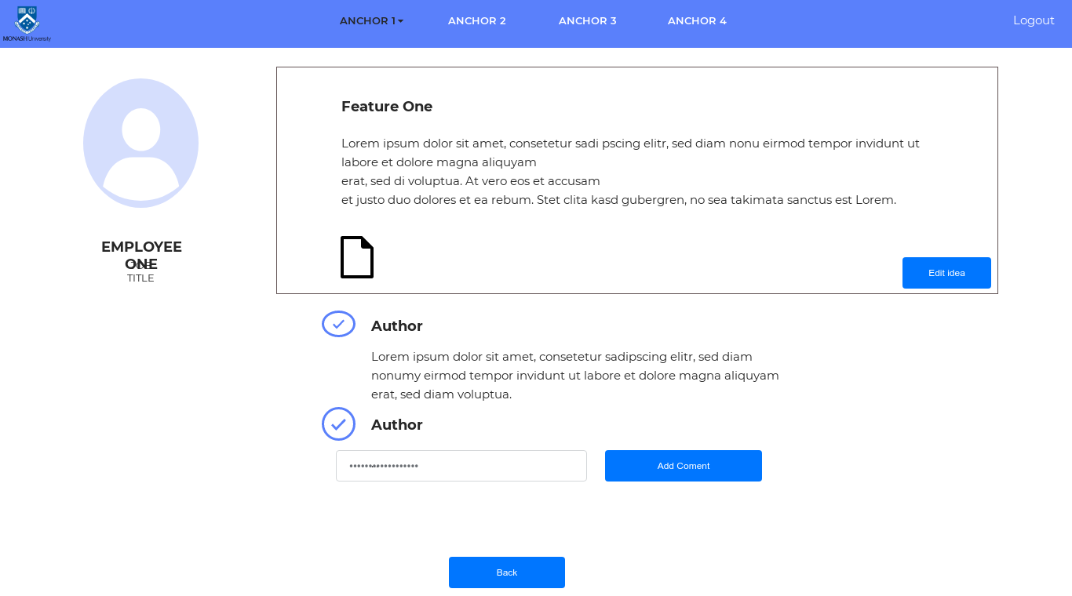

**Analytics page**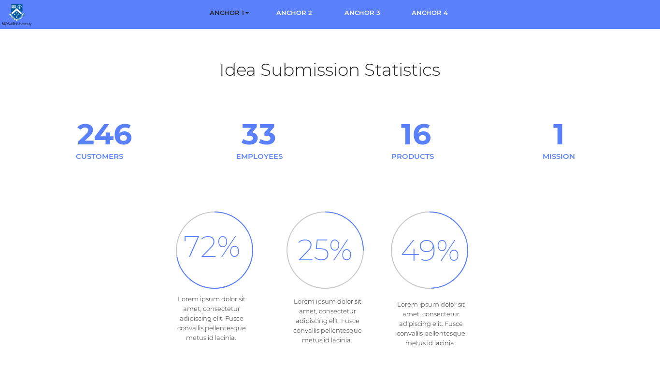

**Administration panel**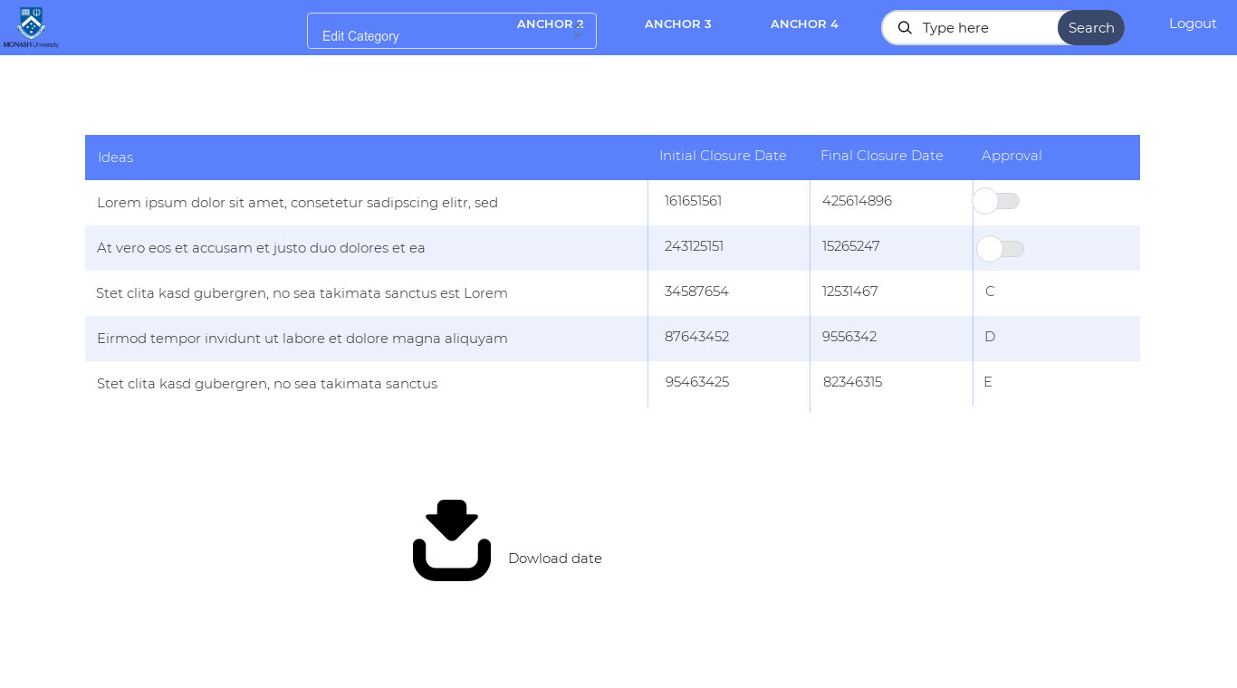

**QA Management**